**Intel IoT Gateway / Arduino 101 with Microsoft Azure**

**Hands-On Workshop**

**Authors:   
Priyanka Bagade | priyanka.bagade@intel.com | @bagadepriyanka**





Table of Contents

Topics covered: Intel IoT Gateway, Grove sensors, Node-RED, Microsoft Azure, Azure IoT Hub.

In this lab, we will unbox and set up an Intel IoT Gateway and the Arduino 101 board (with a Grove Starter kit) along with several services available in Microsoft Azure to monitor the temperature and alert maintenance of a high temperature. Using Node-RED, running on the Intel NUC Gateway, the application will read the temperature value from a Grove temperature sensor.

Getting Started with Grove IoT Commercial Developer Kit 37

Intel NUC Developer Hub Overview 49

Starting Node-RED for Blinky LED 37

Adding Sensors and Processing to the Gateway 49

Sending data to Azure Cloud 37

## Prerequisites

* Intel® IoT Gateway Technology running IDP 3.1 or above with internet access
* A development device (e.g. laptop) on the same network as the Intel® IoT Gateway
* Terminal access to the Intel® IoT Gateway from your development device
* Microsoft Azure account: <https://portal.azure.com/>

Getting Started with Grove IoT Commercial Developer Kit

## Step 1 - Unboxing Grove IoT Commercial Developer Kit and Arduino 101

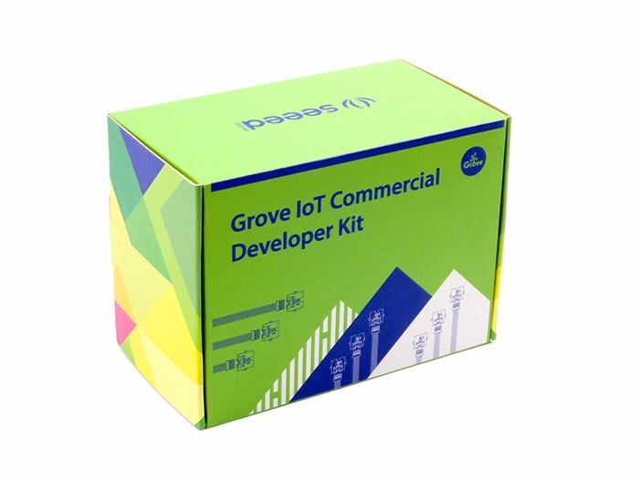

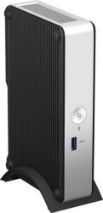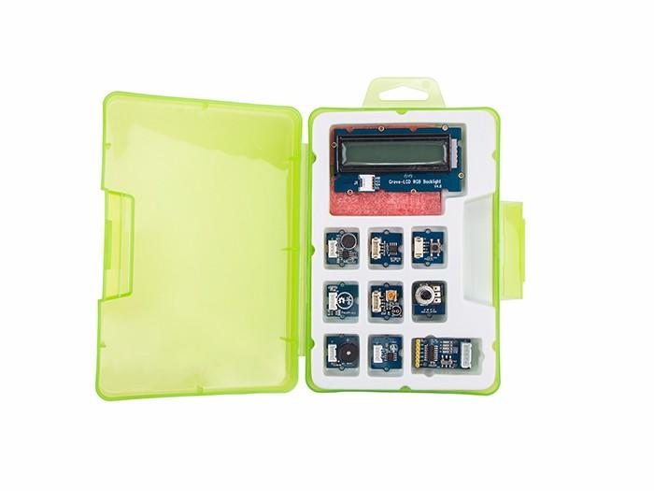

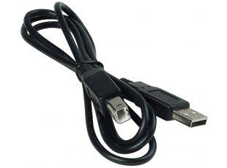

Arduino 101 is not included in Grove IoT Commercial Development Kit and will be given separately.

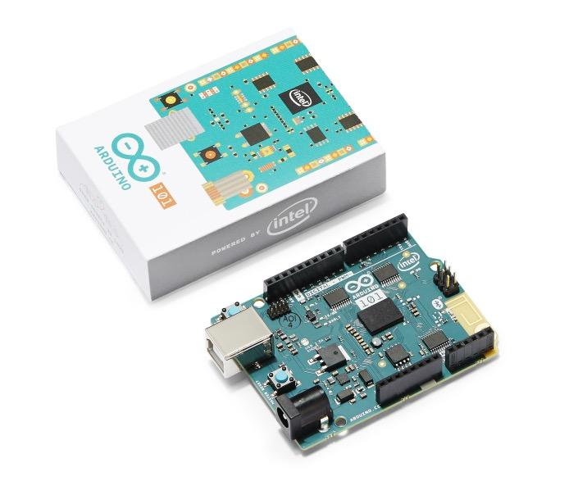

## Step 2 – Connect Base shield to Arduino 101

Base shield will be included in the Grove starter kit. Attach the Grove base shield to the Arduino 101.

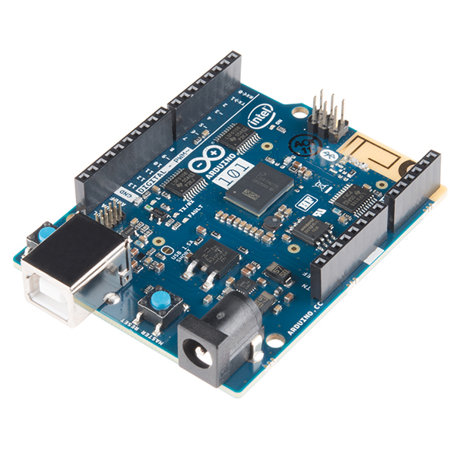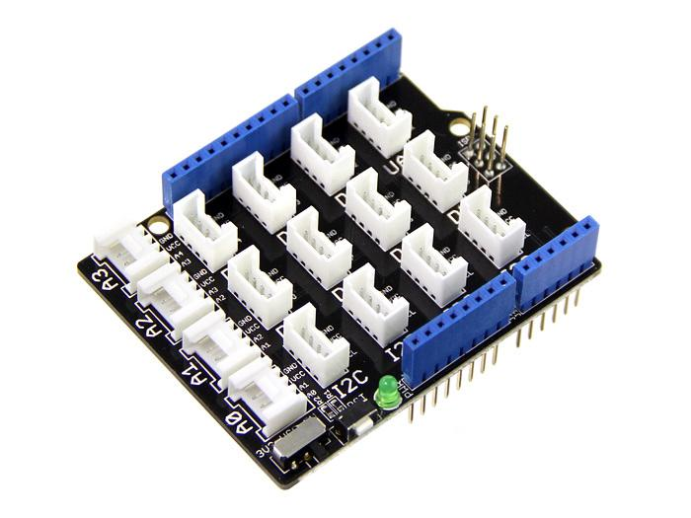

## Step 3 – Move Base Shield switch towards 5 Volt

## 

## 

## Step 4 – Connect LCD and Rotary Angle to Arduino 101

Connect LCD to any I2C socket and rotary angle to A0 socket with a grove connector cable as shown below, the cables are in the green box.

## C:\Users\vagheshp\AppData\Local\Microsoft\Windows\INetCache\Content.Word\Untitled.jpg

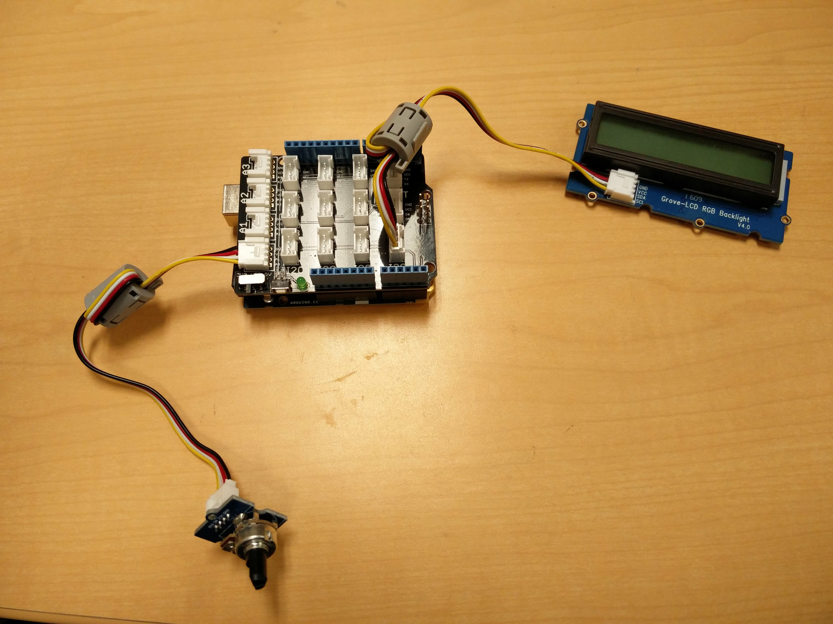

## Step 5 – Connect Arduino 101 and Intel IoT Gateway via USB A-B Cable

Now connect Arduino 101 with Intel IoT Gateway via USB A-B cable.



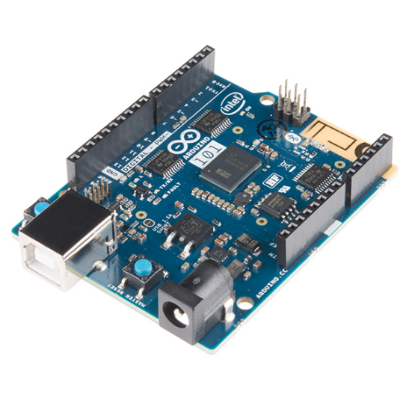

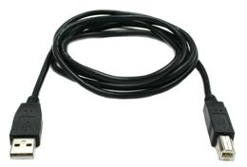

## Step 6 – Connect Intel IoT gateway with Ethernet cable and Power adapter

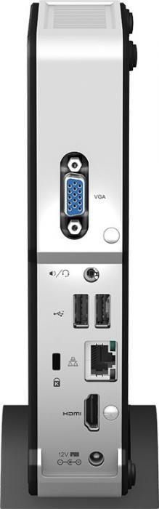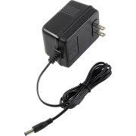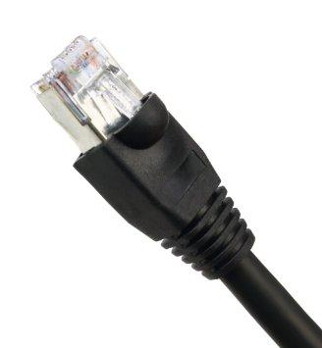

## Step 7 – Press Power button to start Gateway

Press power button to start gateway. After around 2 minutes, it will display the IP address of Gateway on the LCD. **Note down the IP address.**

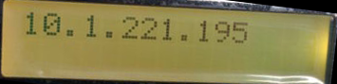

## Step 8 – Open your browser and go to IP address to access the IoT Developer Hub

* Login to the Intel® IoT Gateway Developer Hub using root for both the username and the password.
* Use the Intel® IoT Gateway Developer Hub to explore and extend the basic capabilities of the Gateway.

Intel NUC Developer Hub Overview

The Developer Hub is a front end interface for the Gateway. It has 5 main functions:

* Display sensor data and basic Gateway information on a configurable dashboard
* Access the Node-RED development environment
* Add repositories, install and upgrade packages
* Administer the Gateway – update OS, configure network setting
* Access documentation

# Dashboard

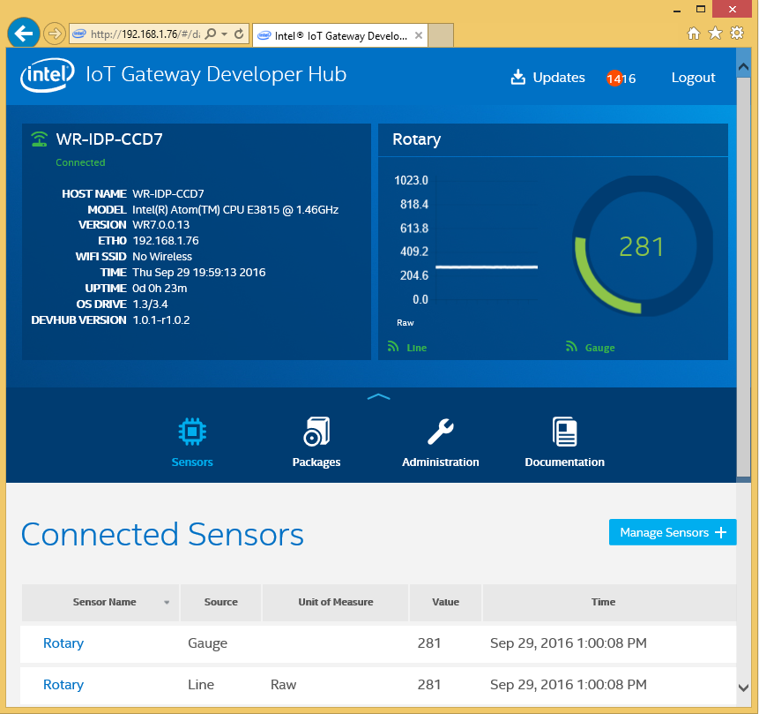

**Dashboard with Rotary Angle Sensor Data**

By default, the Gateway is programmed to display the value of the rotary angle sensor (knob) on the dashboard. Twist the knob to see the gauge move.

# Package Manager

On the package manager interface you will most likely see an option to “Install Updates”.

**Do Not Install Updates!** This process can take a significant amount of time and will use up a lot of bandwidth.

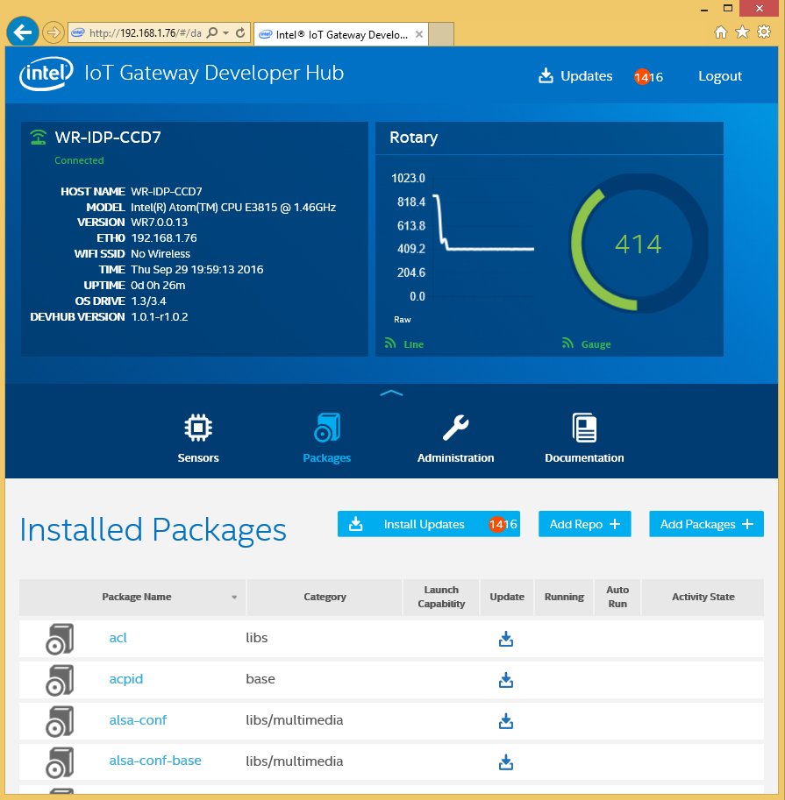

# Administration

In the Administration interface you will see options to Update the OS, Upgrade to Pro, as well as others.

**Please do not select any of these options!**

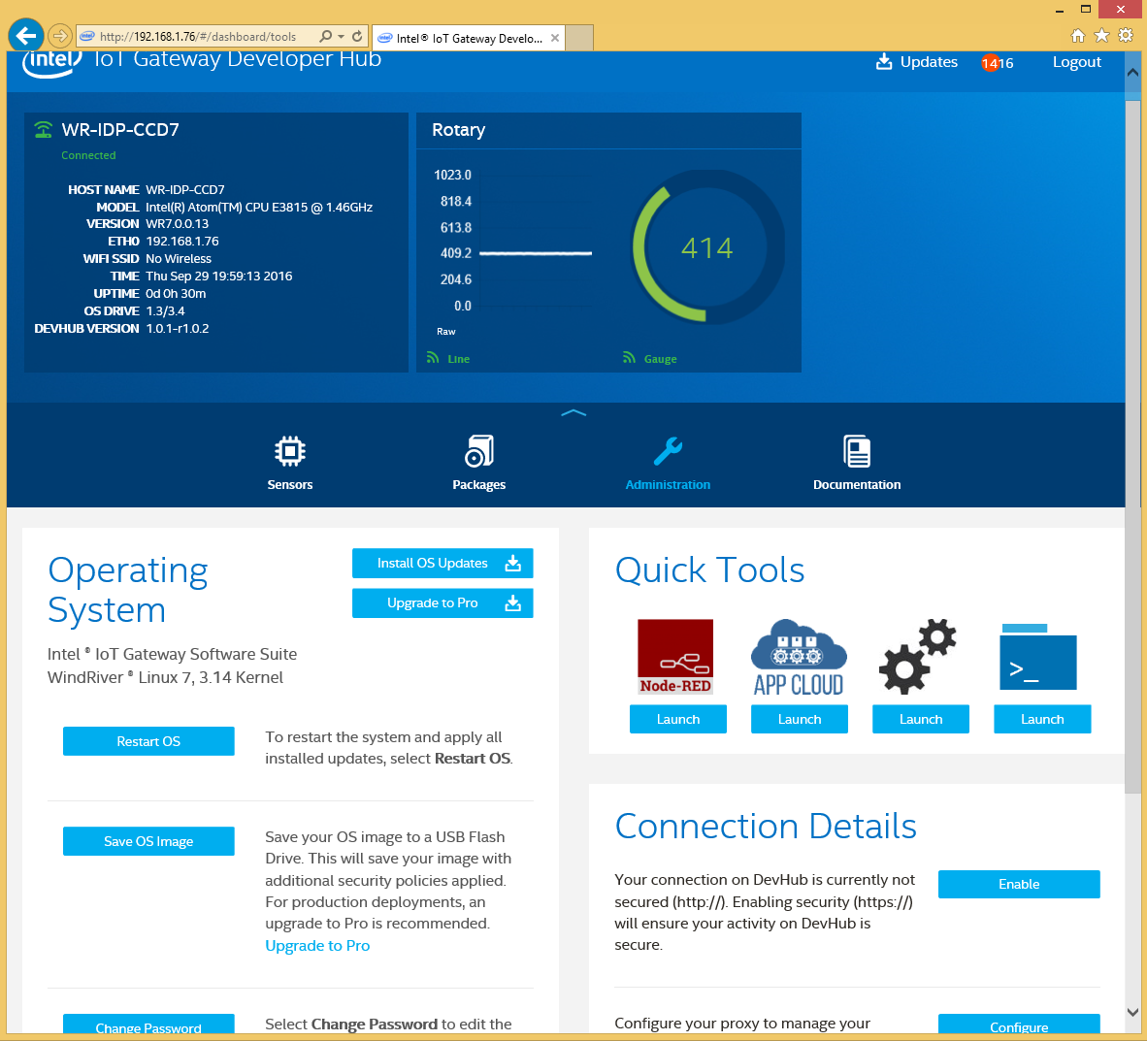

Further down on the page you will see links to some quick tools. Feel free to explore these, however:

**Please do not alter any settings in the configuration tool (two gears)!**

# Documentation

The Documentation tab will give you links to some of the documentation for using the Gateway.

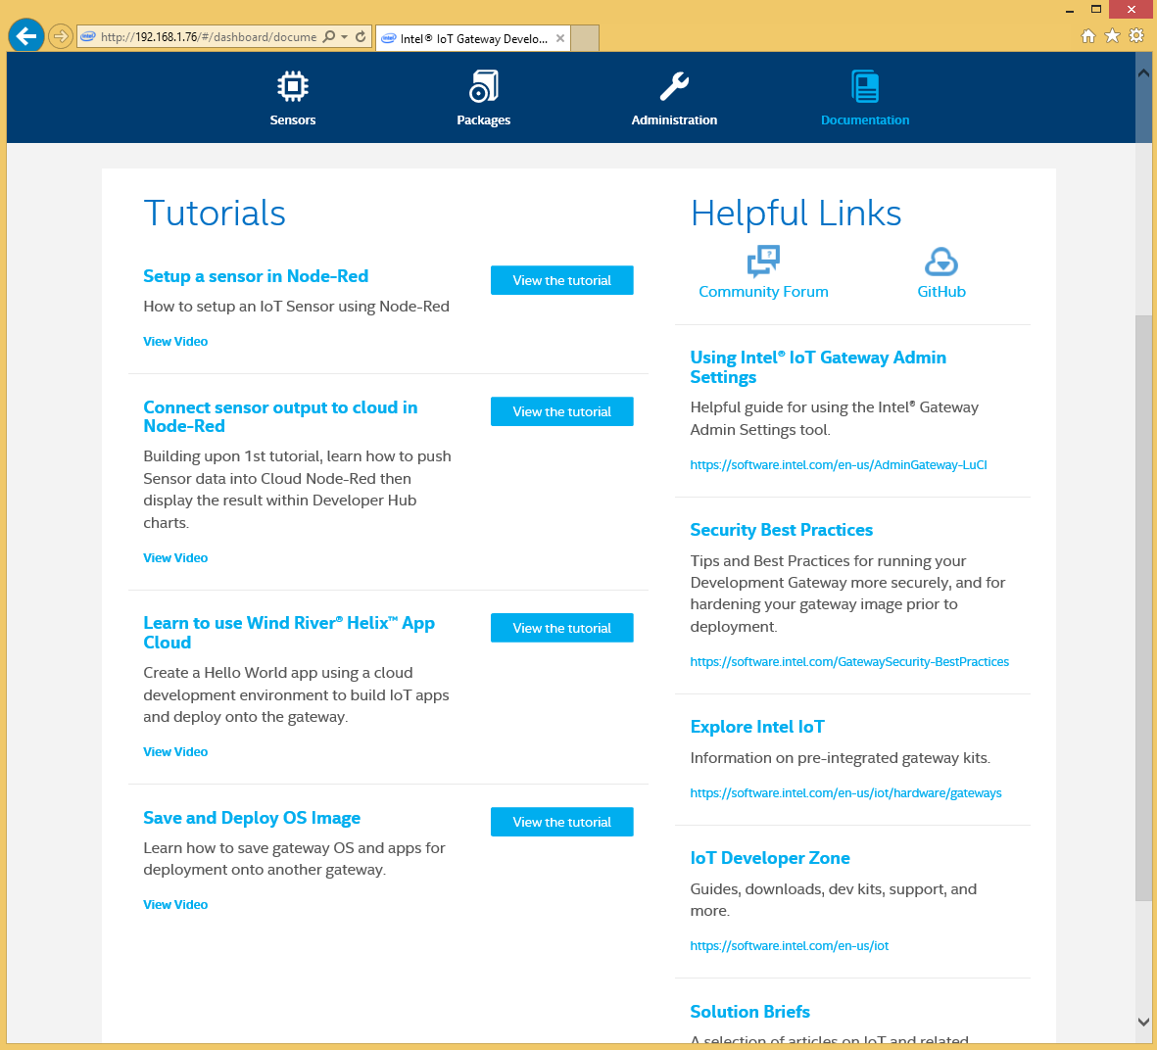

# Connect to your Gateway with a terminal client

In order to perform advanced configuration of the Gateway either a monitor and keyboard, or a Secure Shell (SSH) connection is required. On OSX and Linux there are default programs that can do this - Screen and SSH respectively. However on Windows no default exists, however Putty is light weight and easy to install and can be used to SSH into the Gateway.

# For Windows Users:

* + Visit the [PuTTY download page](http://www.chiark.greenend.org.uk/~sgtatham/putty/download.html).
  + Under the "For Windows on Intel x86" heading, click on the "putty.exe" link to download the latest release version to your computer. 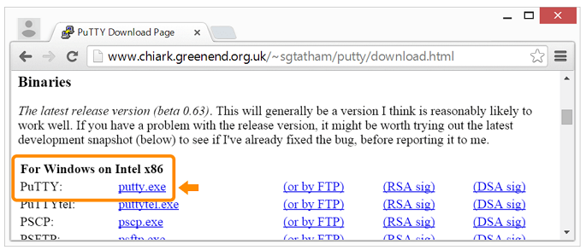
  + Double-click putty.exe on your computer to launch PuTTY.
  + Enter IP address of the Gateway
  + You can login with the username **root** and the password **root**.

# For Mac and Linux Users:

* + Open a Terminal
  + Type $ *ssh root@<<IP Address>>. Replace <<IP Address>> with the IP address of your gateway.*
  + Enter ***root*** as password

Starting Node-RED for Blinky LED

* Go to Development Hub by entering the IP Address assigned to your Gateway

(Eg. <http://192.168.1.1> ) in your browser.

* To load the Node-RED interface, click **Administration** on the navigation ribbon. Click **Launch** under the Node-RED icon.

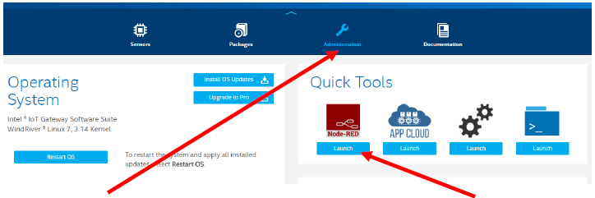

* Node-Red is a visual tool for writing the Internet of Things (IoT).
* Enter username and password as **root** and **root** respectively.

You will see the default application that sends the IP address to the LCD screen and the rotary angle sensor data to the chart on the dashboard. Leave this flow as is for now.

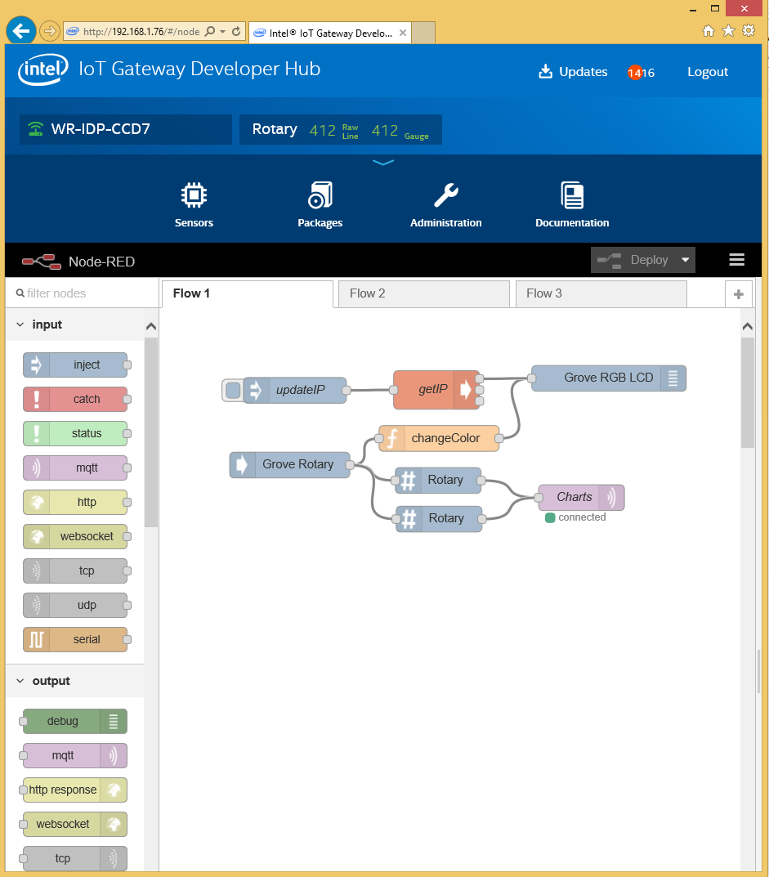

Create a new flow to program the rest of the exercises. Click the + button in the upper right corner of the Node-RED interface.

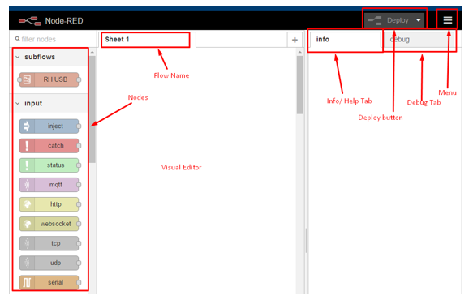

* **Deploy Blinky LED Node**. Go to Nodes, at the bottom of page there will be group on Nodes called UPM Sensors. Drag Grove LED from Nodes to Visual Editor

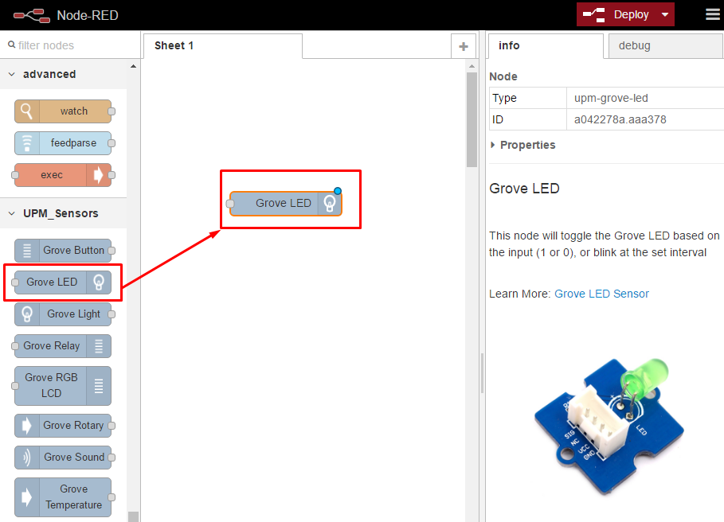

* Double Click on Grove LED node on visual Editor. It will open a dialog box to edit properties of node.
  + Name – Blinky LED
  + Platform – Firmata
  + Pin – D13
  + Mode- Blink
  + Interval(ms) – 1000

Then Click OK to save changes.

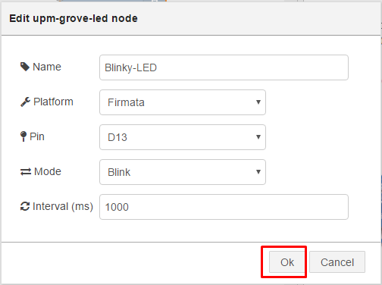

* Click the Deploy button on the top of menu bar to deploy the Node-RED flow.

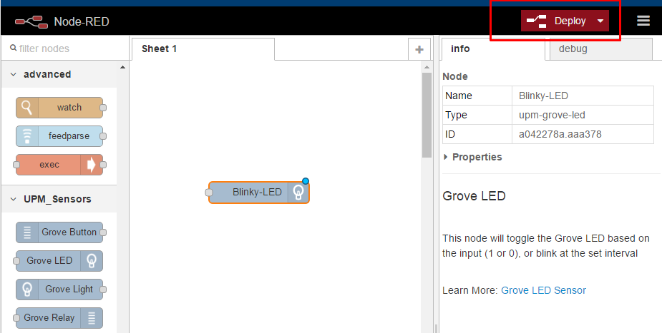

* The Arduino 101 LED on board LED will start blinking

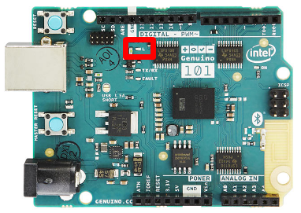

Adding Sensors and Processing to the Gateway

Now that you have a basic understanding of how to interact with the Gateway. Let’s move on to adding some more sensor data and processing to the gateway.

We will create Node-red flow to get data from temperature sensor and display it on debug window. We will be extending this flow to send data to Azure IoT hub in next lab module.

**Create Temperature Flow**

We will now create a flow to measure the local temperature and send the data to Microsoft Azure IoT Hub. First Plug in a Grove Temperature sensor into A1 using a grove cable:

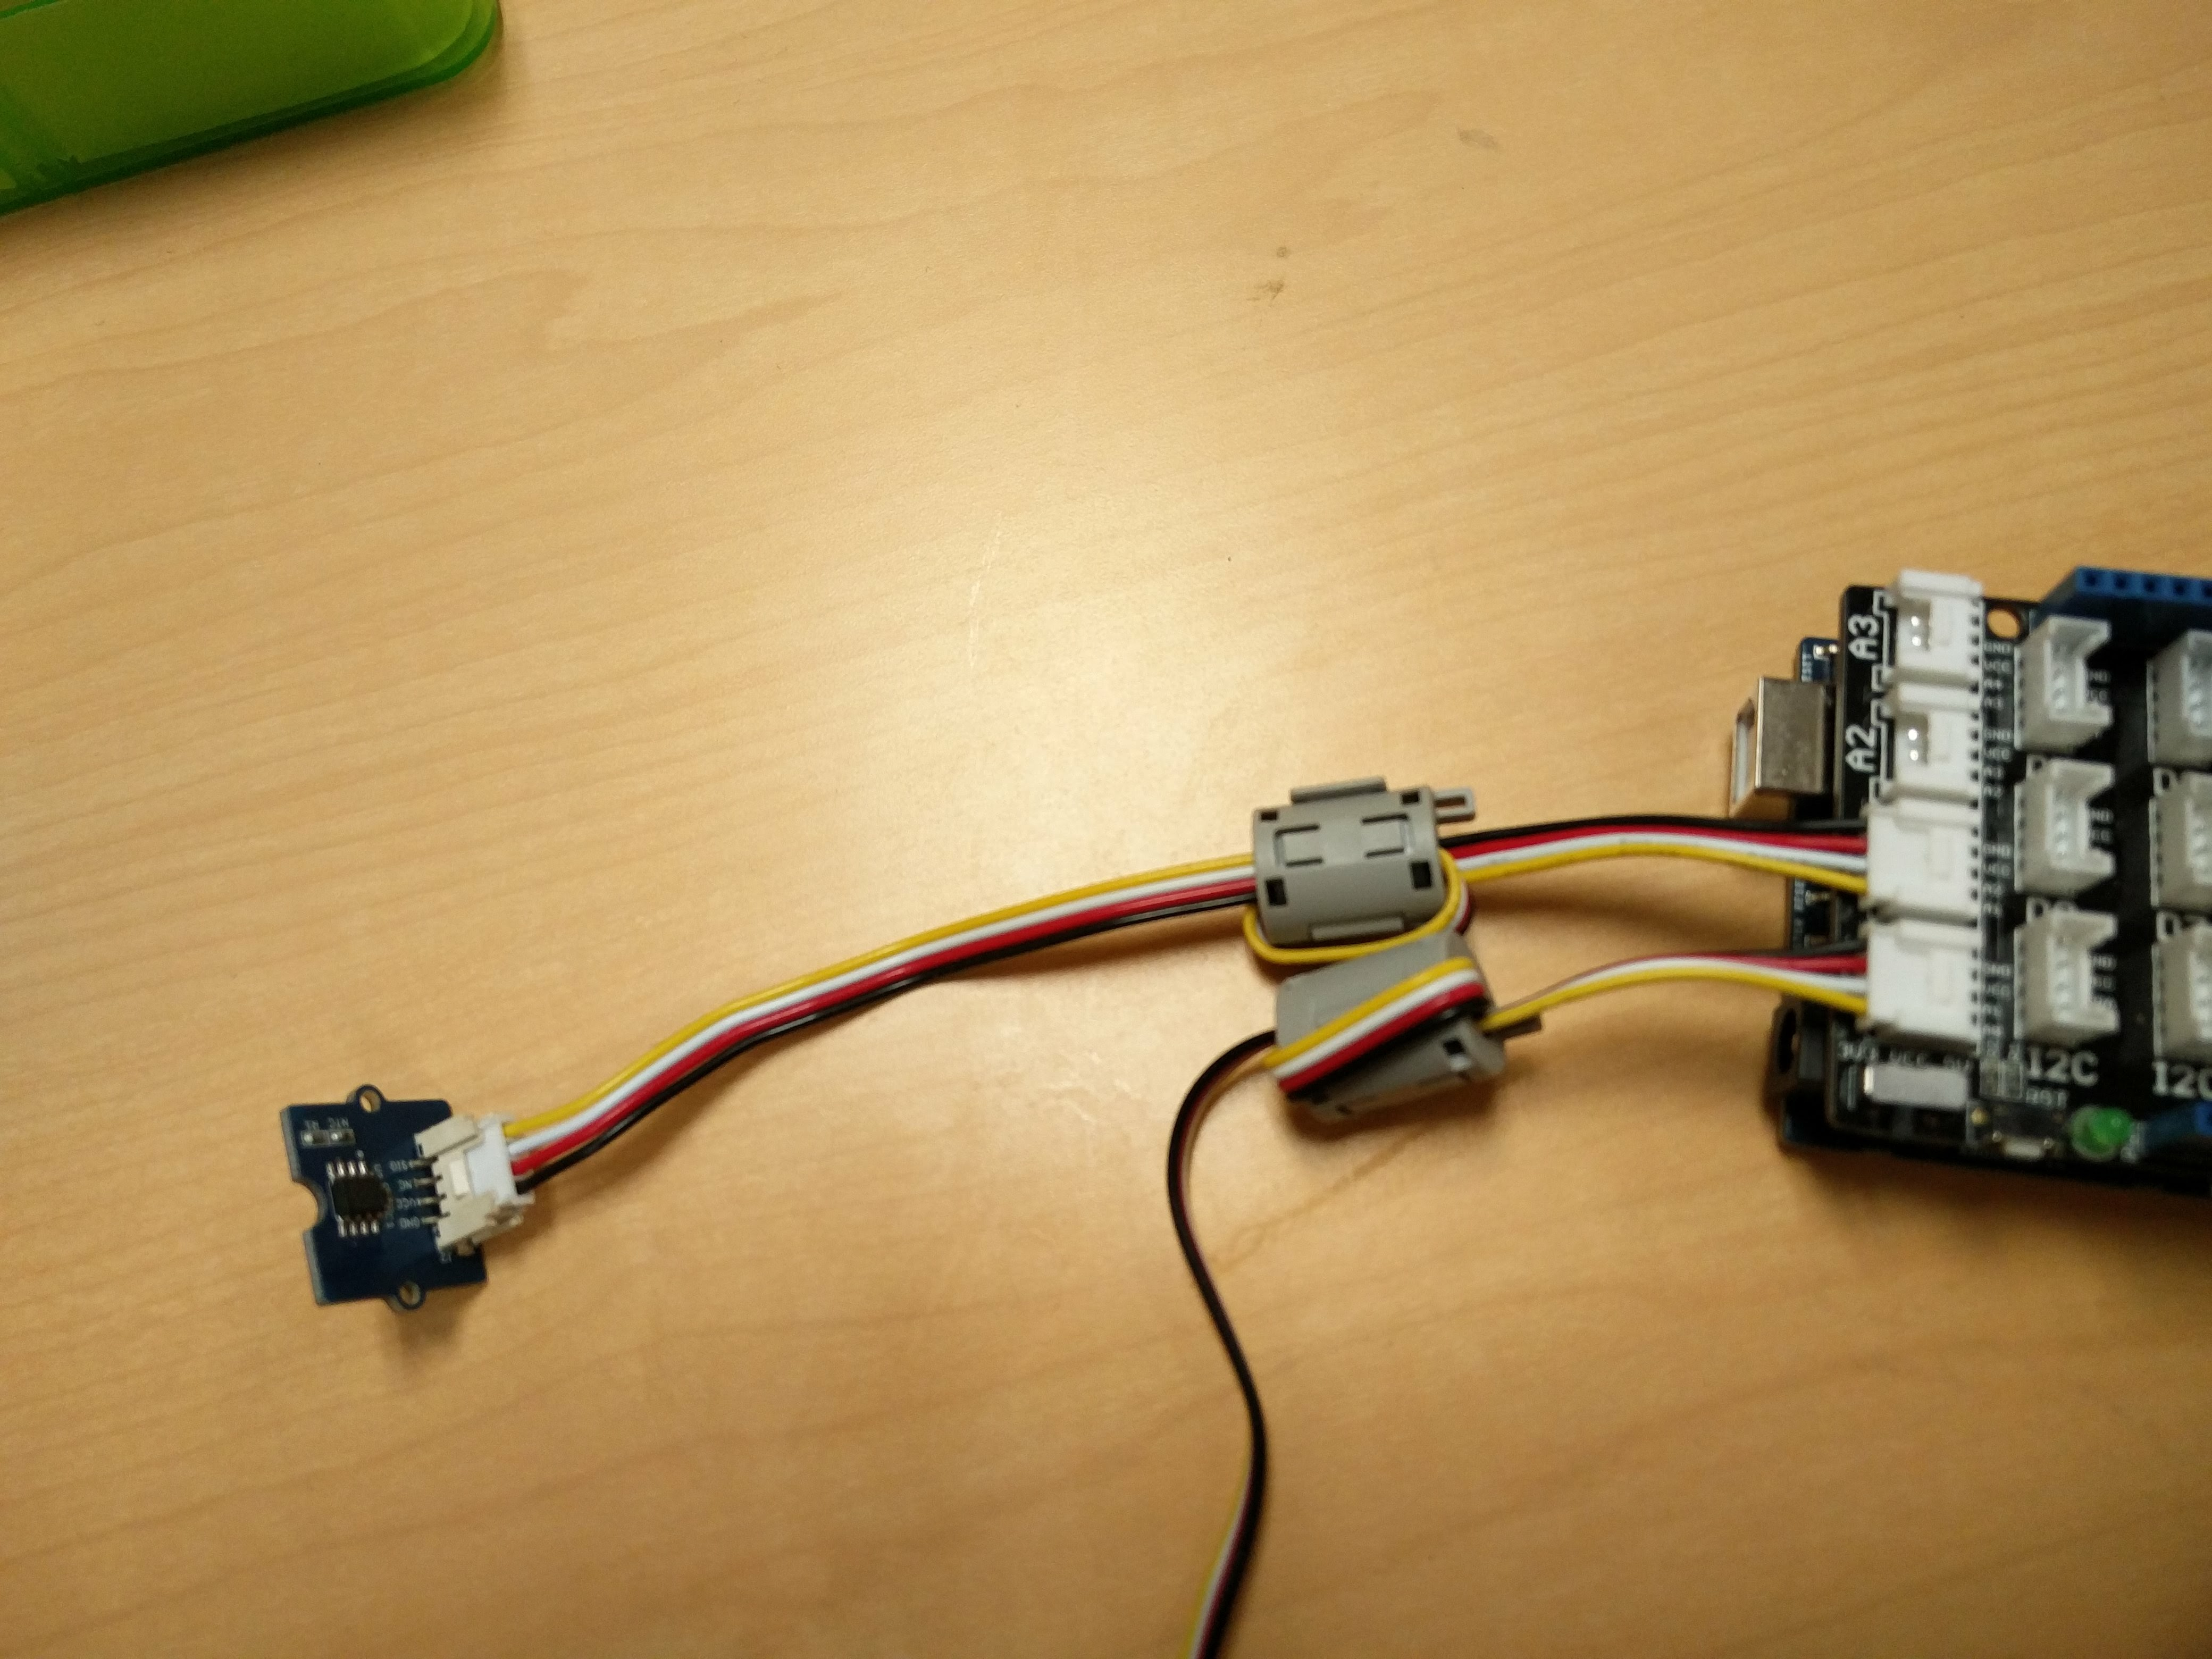

Once the Gateway reboots go back to your Node-RED, create a new flow and add the following nodes:

* From **UPM_Sensors** add a **Grove Temperature Sensor** node
* Double click the **Grove Temperature Sensor** and change the **platform** to **firmata** and the pin to **A1**
* From **function** add 2 **function** nodes
* From **function** add a **json** node
* From **output** add a **Azure IoT** node
* From **output** add a **debug** node
* Wire the nodes as shown below

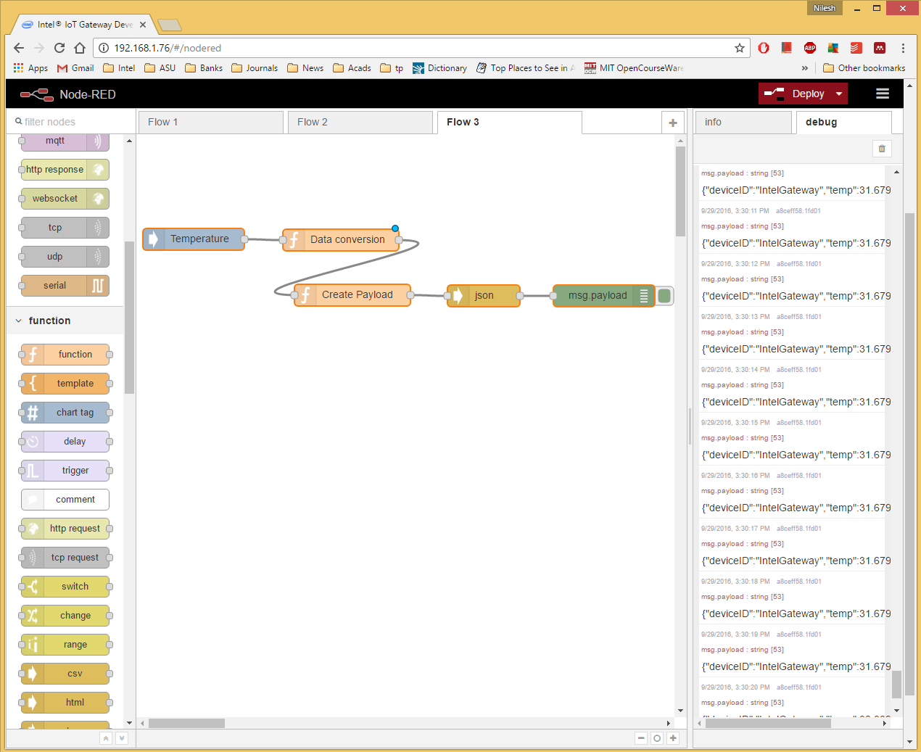

* Double click “Data Conversion” function to add:

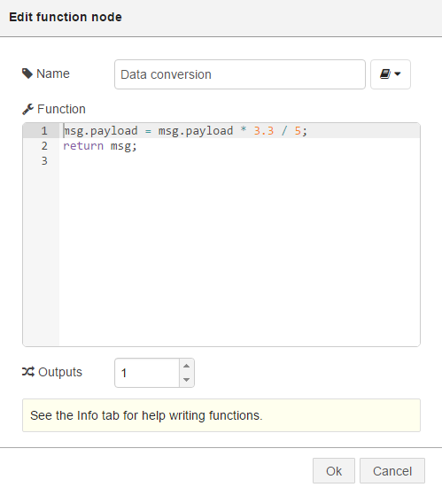

This will allow the correct temperature to be read at a 5V board voltage (the sensor functions at 3.3 by default)

* Double click on “Create Payload” function to add:

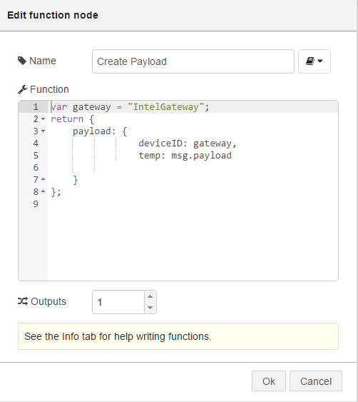

This will format the temperature to allow Azure IoT to ingest the data easier.

Once you have configured the Azure IoT Device nodes your flow will send local temperature data to Microsoft Azure IoT cloud services.

Add Azure IoT Nodes

Next we will add some custom nodes in order to connect to Azure IoT.

1. Open a command line interface to the Gateway. You can do this using the SSH interface of your choice or with the built in command line on the Gateway.

2. SSH into the ip address displayed on the LCD as root. The password is root. Once you are connected to the command line enter the following to add the repository key to rpm:

# rpm –-import <http://iotdk.intel.com/misc/iot_pub.key>

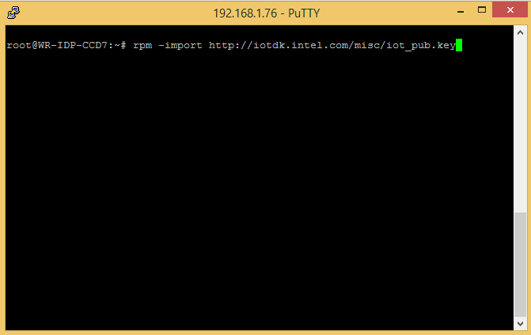

3. Also install the Node-RED OS monitoring nodes with:

# npm install node-red-contrib-os –g

The install process will throw some warnings, you can ignore these.

**Add the ‘IoT Cloud’ repository**

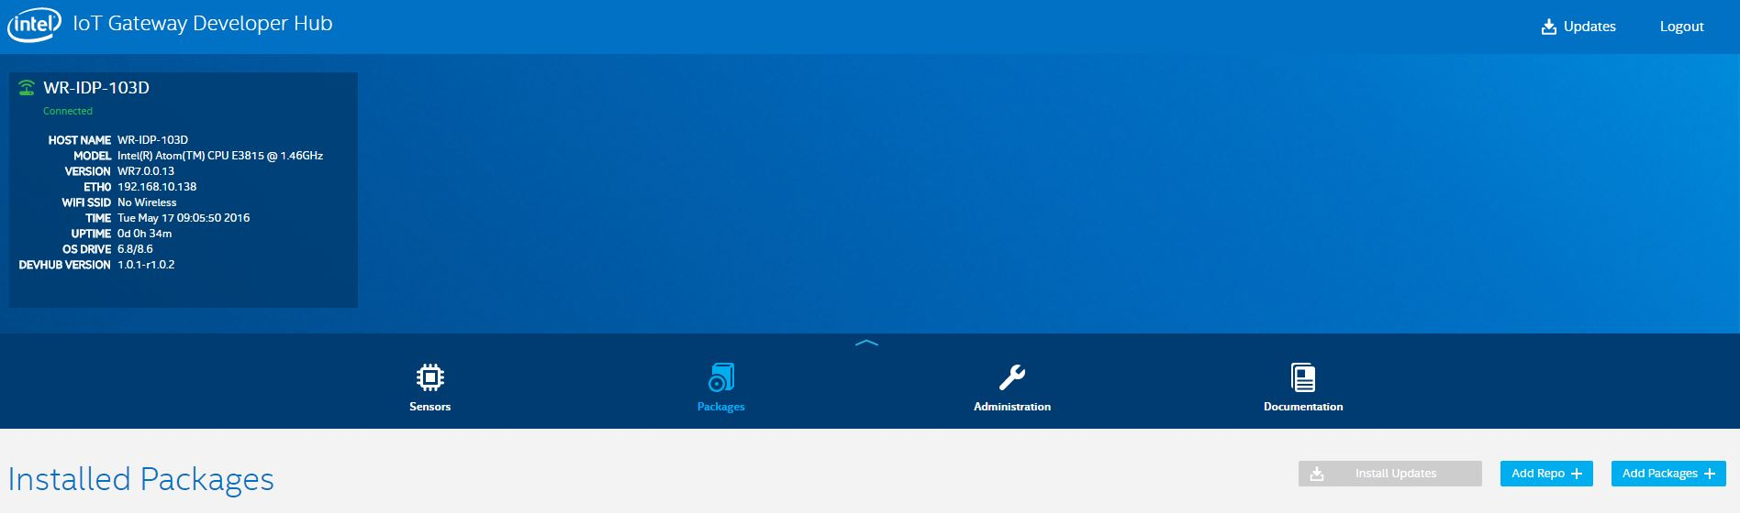

5. Go to the ‘Packages’ section and click the ‘Add Repo +’ button.

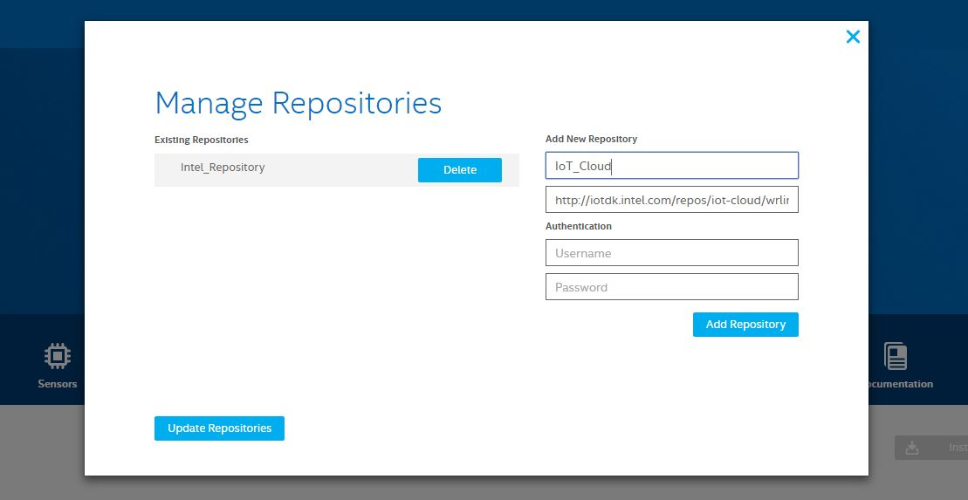

6. Populate the fields with the following information and click *‘Add Repository’*:

Name: IoT_Cloud

URL: <http://iotdk.intel.com/repos/iot-cloud/wrlinux7/rcpl13>

Finally, click the *‘Update Repositories’* button to update the package list.

**7.** Adding Microsoft Azure support to your Intel® IoT Gateway

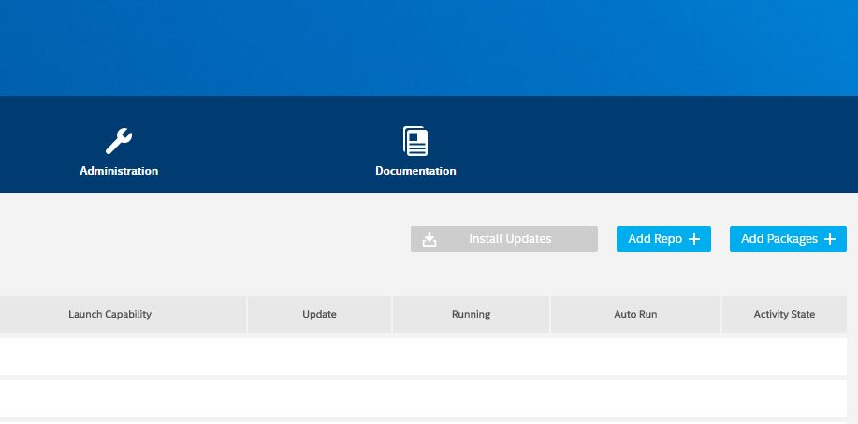

Click the *‘Add Packages +’* button to bring up the list of packages you can install.

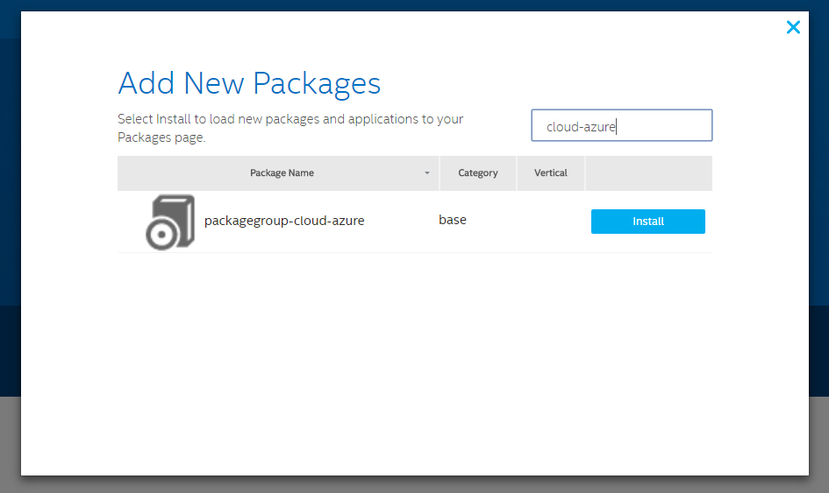

Search for *‘cloud-azure’* using the search box at the top of the package window. Click the *‘Install’* button next to the ‘*packagegroup-cloud-azure*’ entry.

8. After installing the Azure cloud package the Node-RED service needs to be restarted so it can pick up  
the newly installed nodes. Run the following command from the gateway’s console:

#systemctl restart node-red-experience

Modify Temperature flow to add Azure node

* Launch Node-red from Administrator tab on Gateway Developer hub:

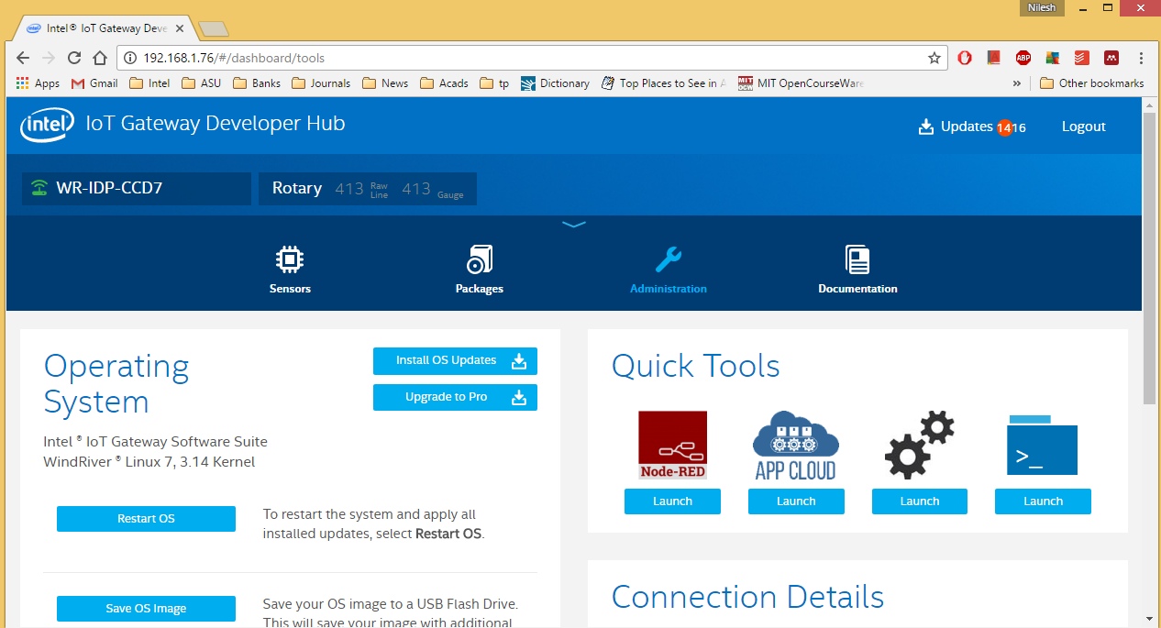

* Add **azureiothub** from **cloud.** Connect the **json** output to the **Azure IoT Hub** in the flow as shown below. We have to setup Azure IoT hub before we deploy this flow to send data to Azure.

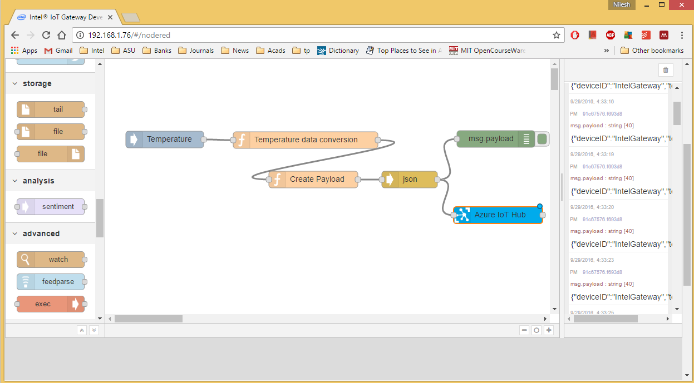

What Next?

To explore some advanced projects that you can build with the gateway make sure you have the Intel XDK IoT Edition up and running and check out:

**Smart Home Path to Product:**

<https://software.intel.com/en-us/articles/iot-path-to-product-how-to-build-the-smart-home-prototype>

**Smart Vending Machine Path to Product:**

<https://software.intel.com/en-us/articles/iot-path-to-product-how-to-build-an-intelligent-vending-machine>

**Connected Transportation Path to Product:**

<https://software.intel.com/en-us/articles/iot-path-to-product-how-to-build-a-connected-transportation-solution>

**A collection of How-To IoT Projects:**

<https://software.intel.com/en-us/blogs/2015/11/04/announcing-18-new-how-to-intel-iot-code-samples>

Setup an Azure* IoT Hub

1. In a browser, navigate to the Azure* Portal at [https://portal.azure.com](https://portal.azure.com/) and log in to your Azure account.

2. Create a new IoT Hub.

a. Select **New** in the top left of the Azure Portal. Select **Internet Of Things** from the list, and select ‘**IoT Hub**.

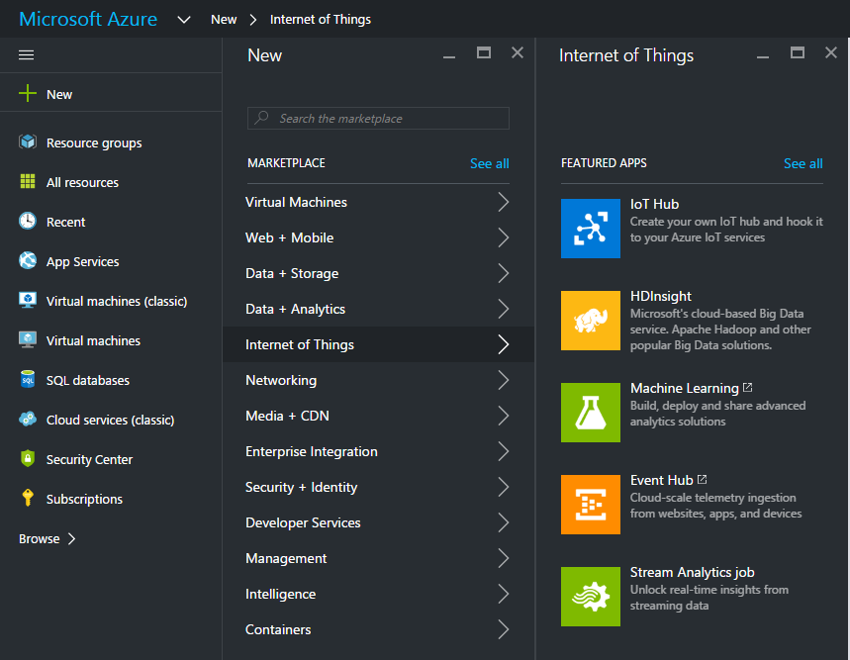

b. Give your new IoT Hub a unique **Name** and select which **Pricing and scale tier** you require.

c. In the **Resource Group** section select **Create New** and give it a unique name in the box provided.

d. Select the ‘**Location**’ nearest to you and click **Create**.

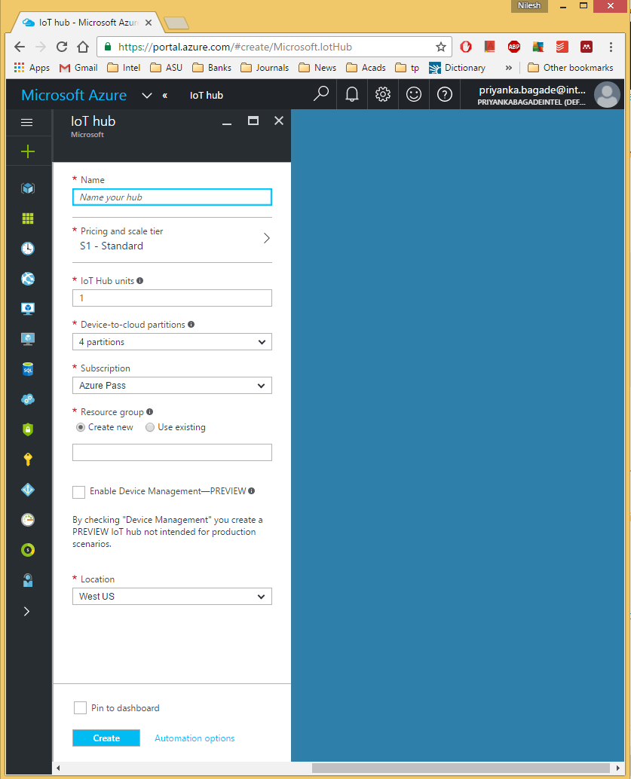

It will take some time to deploy your new Resource Group and IoT Hub, but eventually you should get a **Deployments succeeded** notification.

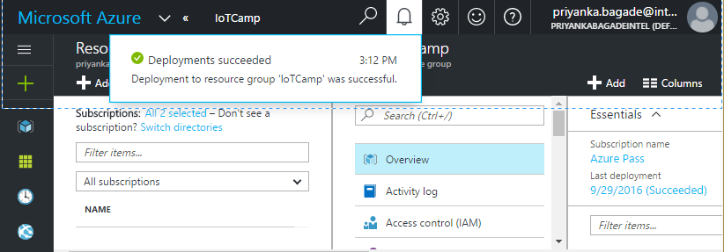

e. Once your new Resource Group has been created, navigate into it by selecting the **Resource groups** option in the left-hand panel and selecting the Resource Group you just created from the list.

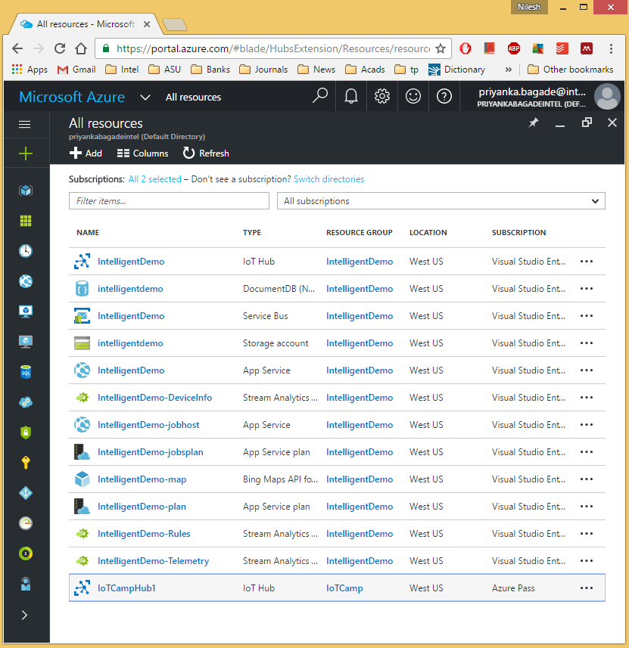

The new group will show its details.

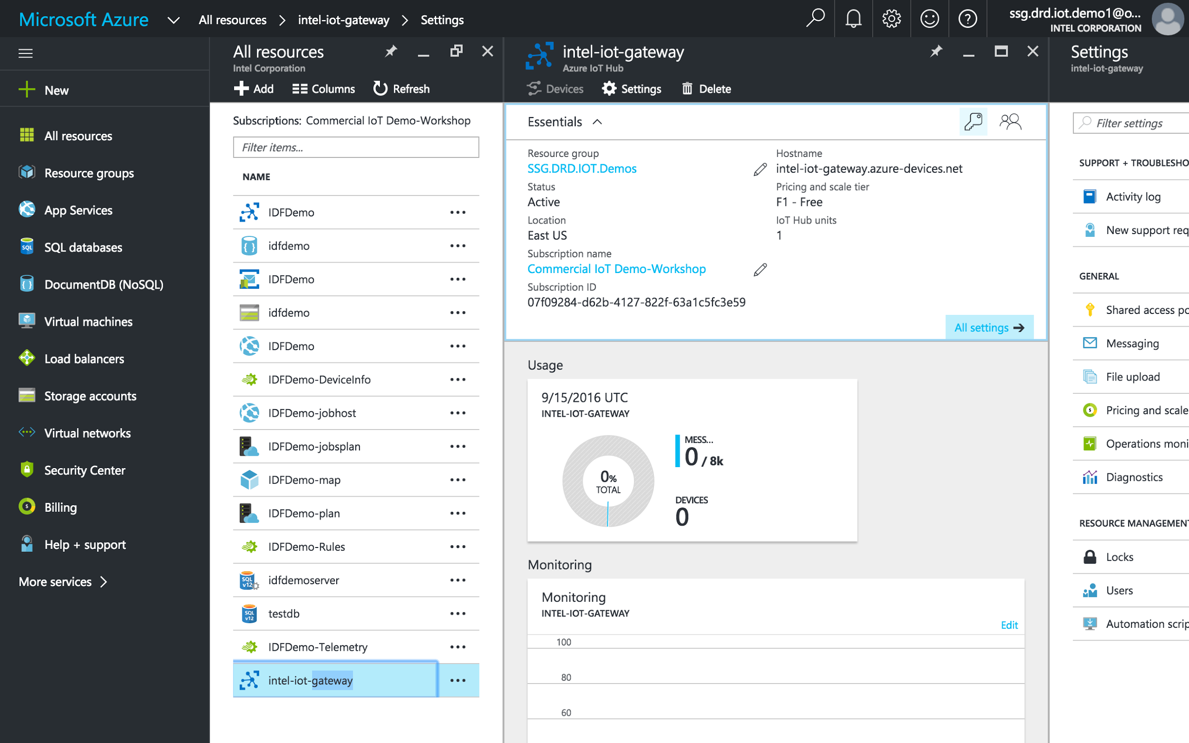

f. Select the IoT Hub you just created from the list, then click the **Keys** icon. Select **iothubowner** from the policy list, then click the **Copy** button next to the **Connection string-primary** key to copy your IoT Hub connection string to the clipboard.

Create a new Azure* IoT Device

1. Enter the following in your gateway’s console to add it to your IoT Hub: 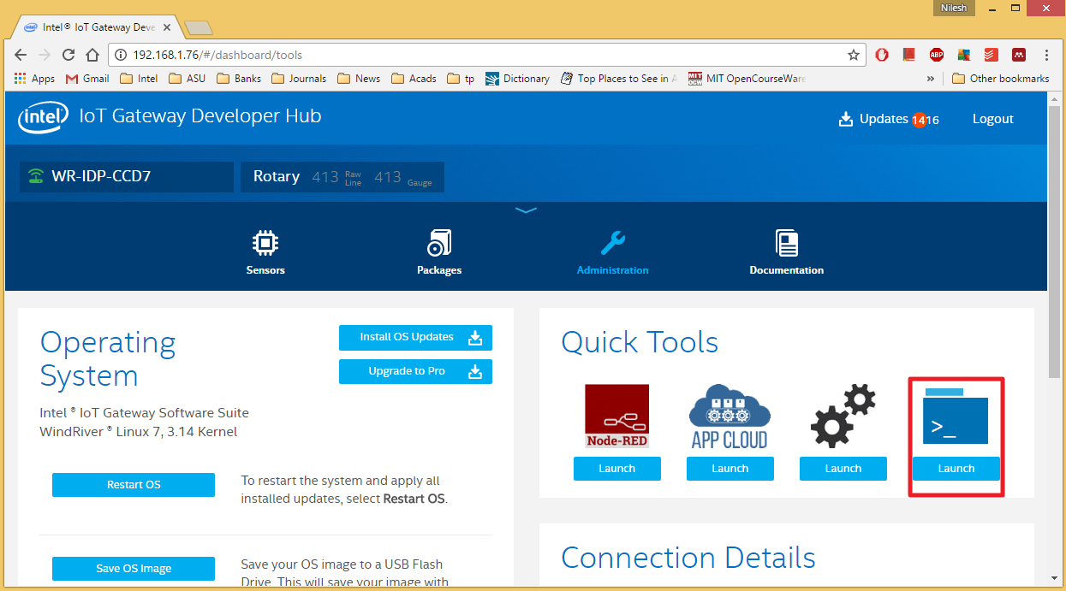Click on the “Quick Tools -> Launch” 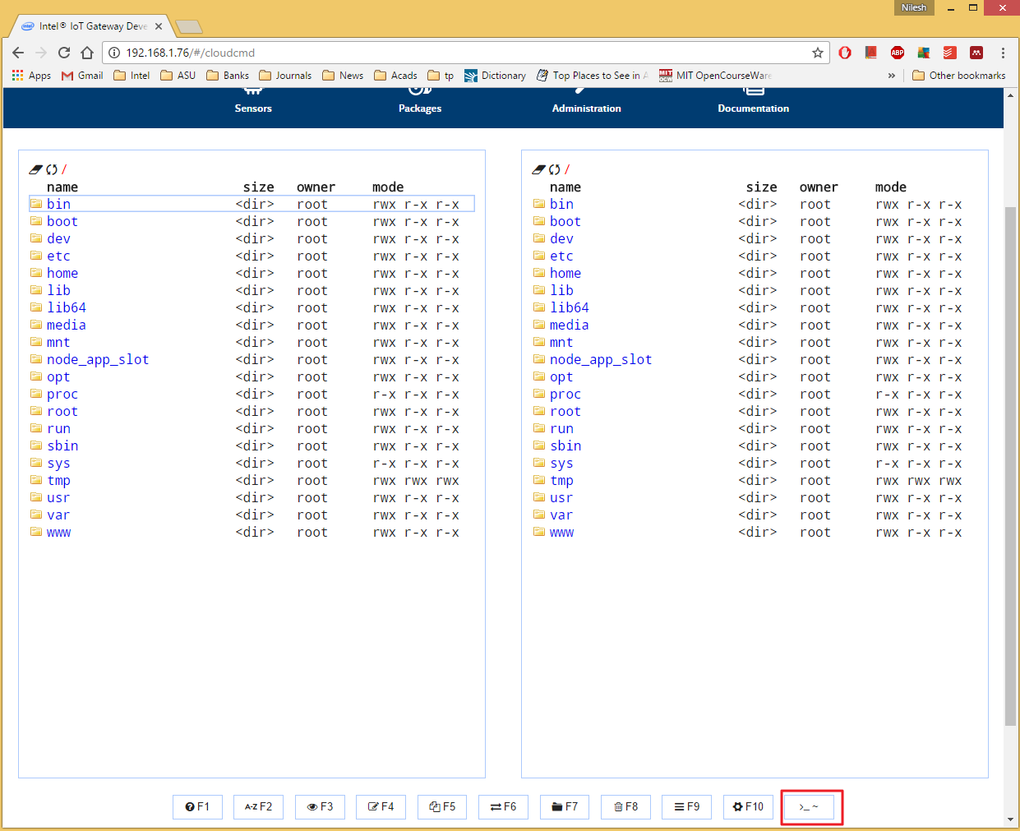

Then click on the button in the lower, right corner. The terminal will display.

Type the following into the terminal

#iothub-explorer "[YOUR CONNECTION STRING]" create IntelIoTGateway --connection-string

If the device is successfully added, you will get output similar to this:

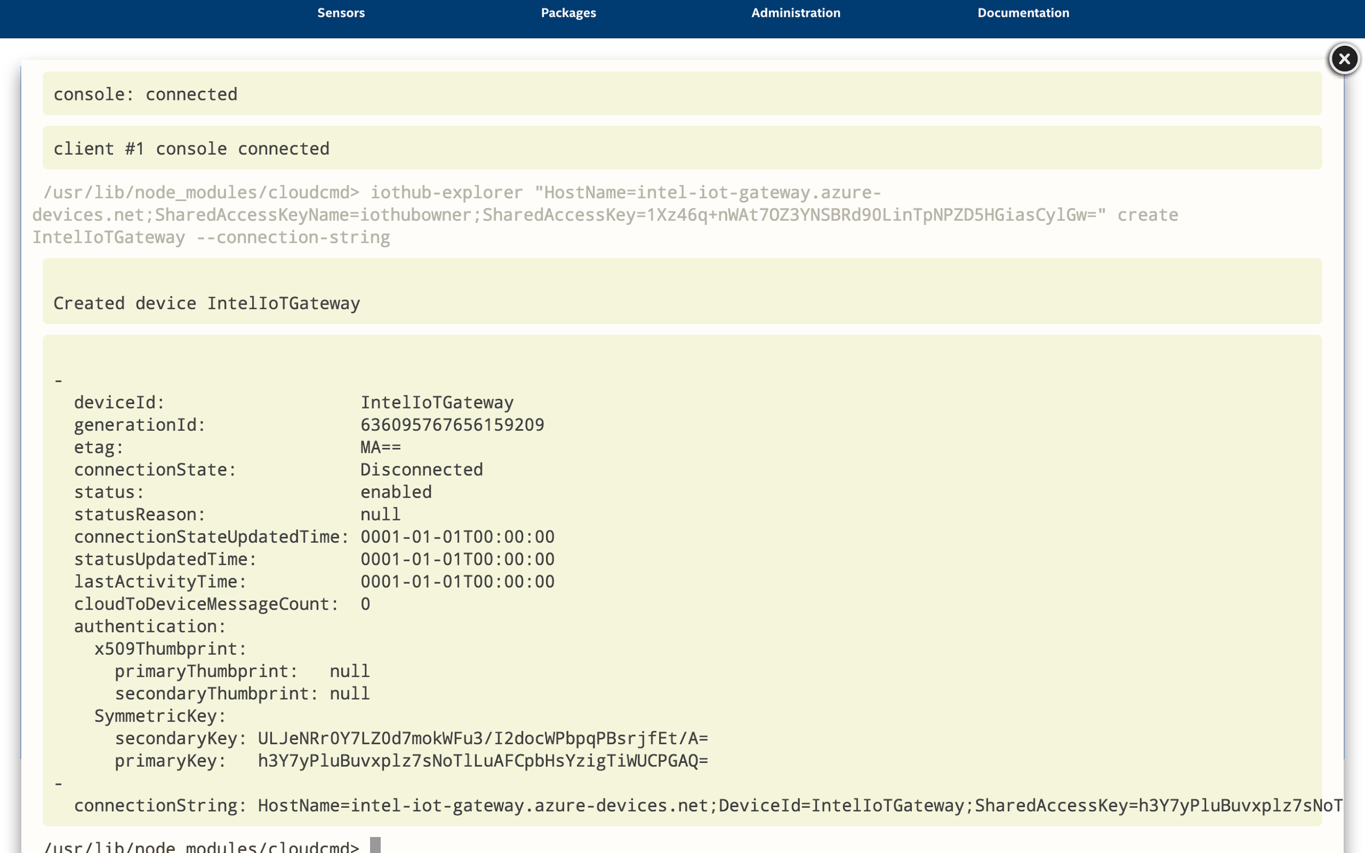

Copy this **device connection string**.

2. Load the Node-RED interface. Go to the **Administration** section of the IoT Gateway Developer Hub and click **Launch** under the Node-RED icon.

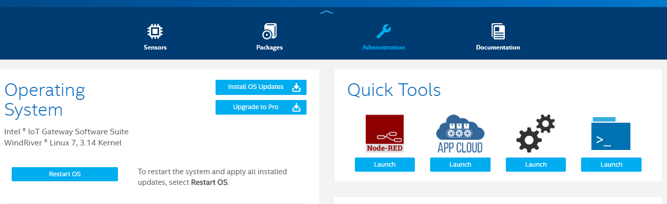

3. Now we will add the **device connection string** in the Node-red flow which we created for temperature sensor,



4. Double-click the **Azure IoT Hub** node to bring up the configuration dialog box again. Add the **device**connection string you copied/saved earlier into the **Connection String** box and click **Ok**. (Make sure you enter the **device** connection string and not the one for your IoT Hub!)

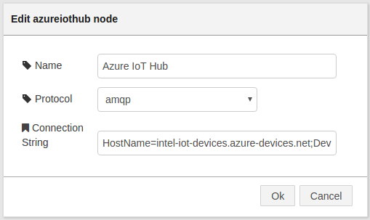

4. Now your flow is configured you can deploy your flow. Click the **Deploy** button in the top right of the screen.

If everything is working correctly, the status of the **Azure IoT Hub** node should change to **Connected** and eventually **Sent message**, as in the screenshot below. A message will be sent to your Azure IoT Hub every five seconds while the flow is running.

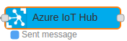

If you navigate back to the Azure* Portal and load your IoT Hub instance, you will see the message count in the **Usage** tile increasing.

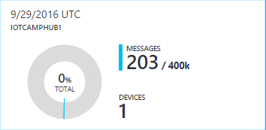

5. Monitor device events (Optional).

You can monitor devices in your IoT Hub using the **iothub-explorer** utility from the command line.

There is also a Windows utility called **Device Explorer** if you prefer a visual application:<https://github.com/Azure/azure-iot-sdks/blob/master/tools/DeviceExplorer/doc/how_to_use_device_explorer.md>

To monitor device events in the command line on your gateway, run the following command:

iothub-explorer "[YOUR IOT HUB CONNECTION STRING]" monitor-events [YOUR DEVICE NAME]

If the Node-RED flow is deployed and running you should see the temperature data being sent to Azure* in the console output similar to the screenshot below.

